**Walk 34 Coddington**

Last walked in May 2018

**Description.** A 5 km (3.1 miles). Coddington, with its thirteenth-century church, is a small village nestling in typical Herefordshire countryside just outside the market town of Ledbury and to the west of The Malvern Hills in an area of outstanding natural beauty.

**Start.** Coddington Church. Explorer Map 190 Grid 718426.

**Directions from Whitecross Roundabout** (Turn milometer to zero). Take the A4110 Canon Pyne (Three Elms road) for 1 mile and TR at the traffic lights onto the A4103 Worcester (Roman road). After 7.7 miles TR, signposted to Stoke Edith. After 9 miles TL at T-junction (not sign posted) onto main road to Ledbury. Reach roundabout at 15.9 miles and go straight across heading for the Town Centre. At 16.3 miles you TL onto the B4214 to Bromyard. At 16.6 miles TR for Wellington Heath. At a T-junction, (17.8 miles) TR for Coddington. TL for Coddington at 18 miles. At a T-junction, (19.4 miles) TL for Coddington. A little further on, (19.8 miles) park in the church car park.

**1. Coddington Church.** ***The early English All Saints Church replaces an earlier Saxon church.*** Out of the car park and TR, walk down the lane and join the minor road as it goes around the church, which is on your R. Continue on down the road, ignore the No Thru Road on the R that goes to Woofields, and 40m further on you TR to go thru a gap in the hedge and into a field **F1**. Go straight up, across this field and to the R of the bricked house in front, to go over a stile into **F2**. Keep to the L edge as you go up this field to cross a stile/metal gates that are in the top corner (a small cottage is on your L). A little further you go down to reach the road. TR and walk uphill, (passing Jobeys Cottage on your L) and continue up to reach the top, where the road veers off to the R.

**2. Concrete Water Tank.** Bear L off the road, (a small concrete water tank is on the L), and continue straight on up a track and into woods, (ignore the track on your L that’s going down hill). Cross a stile/metal gate and a little further on you cross another stile/metal gate. Bear half R; get off the track and onto open ground and head uphill, to reach the trig point on Oyster Hill. Turn half R and walk on past a wooden bench that’s on your L, to continue along the brow of the hill for a short distance to go thru a wooden gate and along an enclosed track, (the woods are on your R). Keep in the same direction and at the end of the enclosed track you go thru a small metal gate and out onto open ground. ***Hope End House is off to the L.***  ***A house of the 1750s was replaced after 1809 by a new one designed by J.C. Loudon, who laid out a picturesque garden around it. The 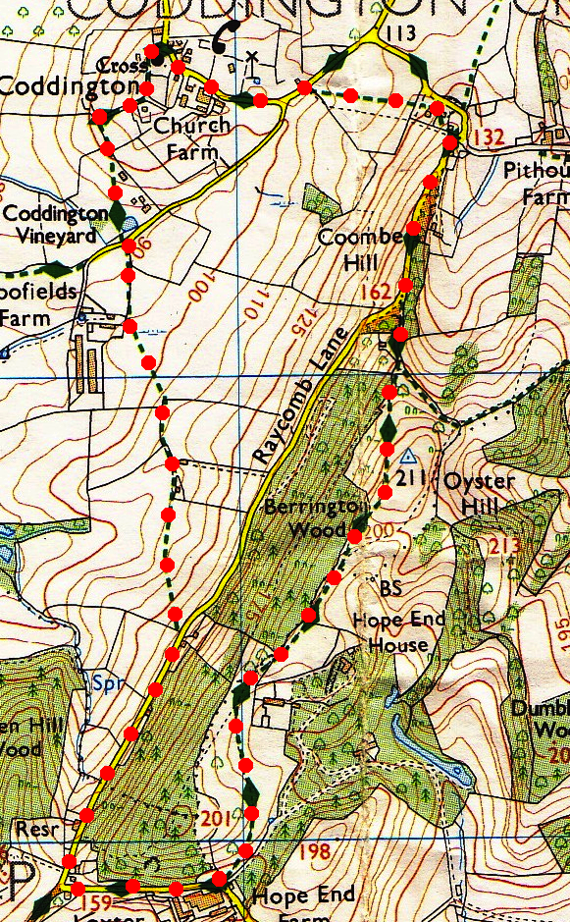house was demolished in 1873 and replaced by the present one.*** After about 120m you bear slightly L and head to the L of two lone trees on the brow of the hill. Continue on, to cross a stile/wooden gate, (Upper Lodge is on your L) and TR when you get onto the road.

**1**

**3. Upper Lodge.** Walk along this road to TR at the first turning to Coddington (Raycombe Lane). After about ½ km, and going past a couple of houses, you reach a black and white house that’s on your R, opposite this house you TL and go thru a small metal gate and into a field **F3**. Turn half R and aim for the L hand corner of the house in front of you, (the house is near to a wooden power line post). On reaching the house corner you continue on across the field to the field corner and cross a stile/metal gate into **F4**, keep to the L edge of this field. Go thru a small/large metal gate, bear slightly L across **F5** to cross a stile into **F6**.

**2**

**4**

**4. Stile.** In the bottom L hand corner you cross a stile into another field **F7** and TR, you then cross a metal stile/metal gate onto a road. TR, 10m along the road you TL and go thru a small metal gate and into a park area. Cross over a wooden footbridge and continue along the edge of the orchard that’s on your R, (pass by a pond on your R). Half way along the orchard edge you TR and walk up a wide grassy corridor in the orchard, to go thru a kissing gate. After 10m you TR and go over two stiles and into a field. TL, walk along the L edge to cross a stile in the corner, then TR and walk along an enclosed track, to reach a tarmac drive (a cattle grid is on the R) where you TL to reach the car park by the church.

**3**

**3**